09032019 Interference Pattern Tracking

**Follow-up questions:**

* Why does the microscope sometimes save a .dm4 file and sometimes a .dm3 file? Is there any significance to the difference? (I believe it has been different on different days.)

**Observation:** Ellipticity in dataset “3” does not come primarily from an elliptical probe per se (the probe might be slightly elliptical, but not much worse than in dataset “2”), but rather from some sort of focus issue leading to two overlapping disks where there should be one only. Depending on the contrast range used in py4DSTEM or elsewhere, this may look like an ellipse, but setting the scale bar correctly shows that it is two overlapping circles. A similar feature can be observed for the hBN peaks in the dataset “2”, though not to the same extent.

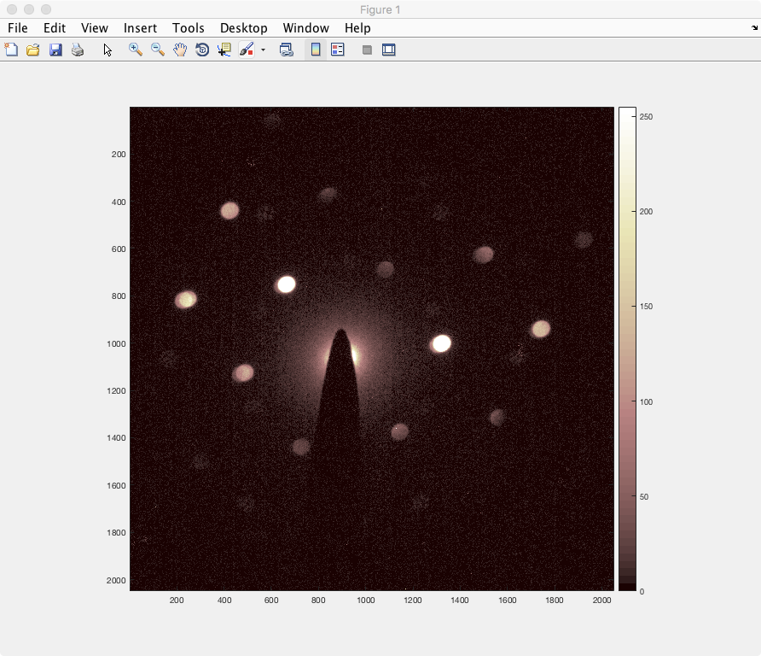

Figure 1: “2_MV_1.5_9_20x20_ss3nm_1s_spot 9_alpha=1_bin1_cl=130_60kV__NPK_nobin.h5”. This is a mere translation of “2_MV_1.5_9_20x20_ss3nm_1s_spot 9_alpha=1_bin1_cl=130_60kV.dm3” into spot size

By comparison, let’s look at the dataset that was previously maligned for being misshapen.

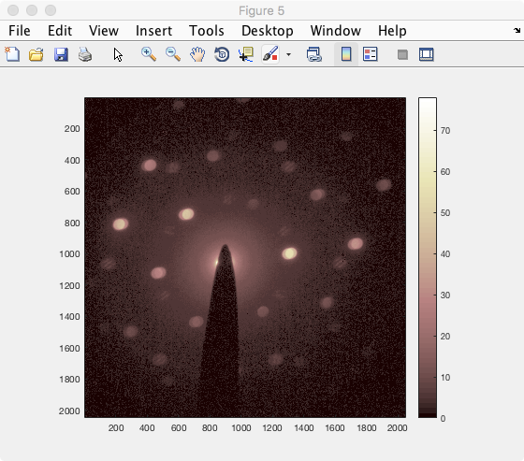

Figure 2: “3_MV_1.5_9_20x20_ss3nm_2s_spot 7_alpha=1_bin1_cl=130_60kV_NPK_nobin.h5”, which is the .h5 translation of “3_MV_1.5_9_20x20_ss3nm_2s_spot 7_alpha=1_bin1_cl=130_60kV.dm3”. (I imaged this by compressing with a square-root filter to keep the intensities on scale in the uint8 representation, but the essential information about probe ellipticity and disk overlap remains the same.)